Stamp Act
Information Sheet
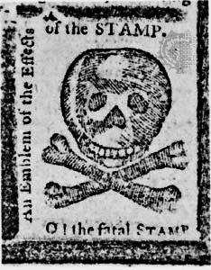
In 1765, Parliament passed the Stamp Act which taxed anything printed on paper by requiring colonists to buy a stamp, or seal, for paper products. Parliament continued to try to raise funds to protect the colonies and pay the debt of the French and Indian War through such taxes. This act caused colonists to resent British rule.
Samuel Adams began the Committees of Correspondence, groups that contacted other towns and colonies about British taxes and how to fight them. One popular protest method was the boycott, where people refuse to buy certain goods in protest. Many colonial women made substitutes for the boycotted British goods. In Boston, Samuel Adams also helped form secret societies called the Sons of Liberty, which were groups of men that protested British policies and sometimes used violence to get their message across.
In 1765, a congress of nine colonies met in New York to discuss the taxes at the Stamp Act Congress. They decided that only colonial governments should tax the colonies and they sent a request to King George III to repeal the act. Benjamin Franklin, representing Pennsylvania, spoke before Parliament and urged them to repeal the act so that colonists could end the boycott and prevent a possible revolution. The protests and boycotts worked and King George III had no other choice but to repeal the Stamp Act. The colonies celebrated the repeal of the act, but they still disagreed with Parliament on many issues. After the repeal, the King approved the Declaratory Act which essentially said that Parliament had full authority over legislation in the colonies.

