Boston Massacre Information Sheet
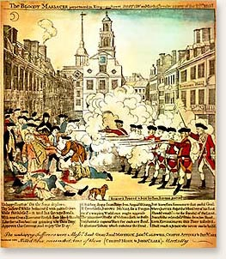
Anger and tension continued to grow as Britain sent more soldiers to Boston when colonists resisted taxes. The tension exploded on March 5, 1770, when a crowd gathered around an angry colonist arguing with a British soldier. Colonists began to shout insults and throw snowballs at the soldier. Soon more soldiers arrived, and as the mob grew louder and angrier, shots were fired. This deadly riot resulted in five colonists being killed that evening, and the event was later branded the Boston Massacre by colonists.
Samuel Adams and other colonists used the incident as propaganda, one-sided information used to influence public opinion. Through the Committees of Correspondence, Samuel Adams shared news and ideas with people in other colonies regarding the incident.
John Adams chose to represent the soldiers in this infamous trial to demonstrate that colonists value the right to a trial by jury for all citizens. He later stated that this was his biggest contribution to his country.
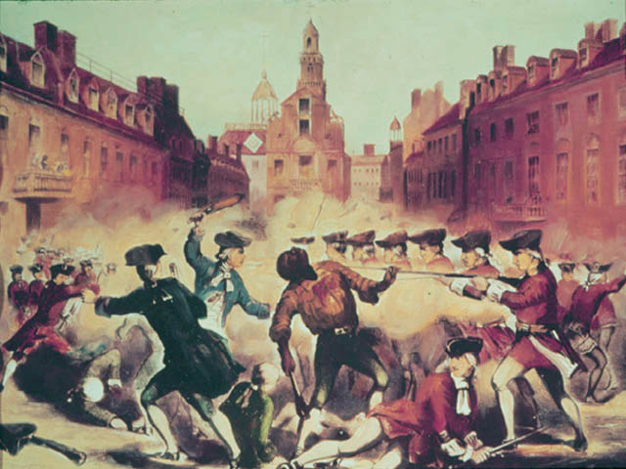Portrait of Crispus Attucks in Boston Massacre http://www.pbs.org/wgbh/aia/part2/2h3147b.html

